Name: Period:
10th Grade World History Date:
The Italian Risorgimento (Means revival in Italian) (1815-1848)
The Congress of Vienna sought to establish a balance of power in Europe, and reestablish former European kingdoms. The settlements reached in 1815 at the Congress of Vienna had restored Austrian domination over the Italian peninsula but had left Italy completely fragmented in a number of small states. The strongest and most progressive Italian state was the Kingdom of Sardinia-Piedmont in north-western Italy. At the Congress of Vienna this state had received the lands of the former Republic of Genoa. This acquisition helped Sardinia-Piedmont expand her merchant fleet and trade centered in the port of Genoa.
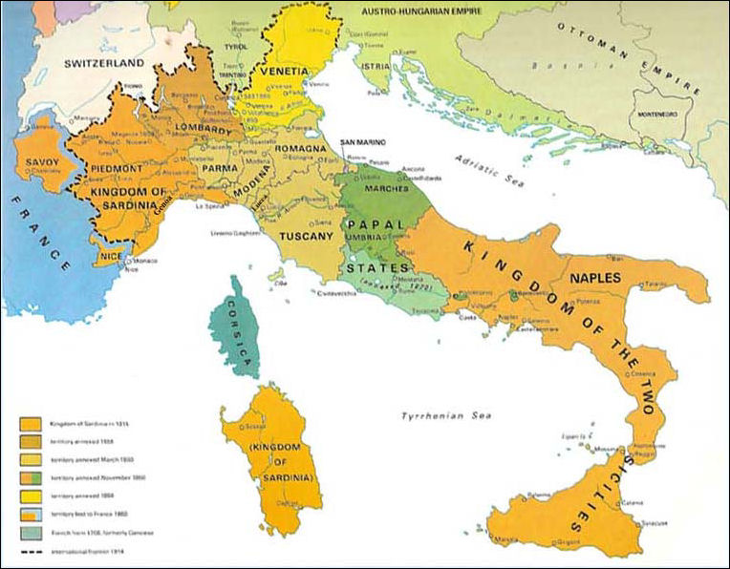
There were three major obstacles to unity at the time the congress took place, i.e. (a) the Austrian occupation of Lombardy and Venice in the north, (b) the principality under the sovereignty of the Pope and Catholic church, i.e. the Papal States that controlled the center of the Italian peninsula; and (c) the existence of various states that had maintained independence, such as the Kingdom of Sardinia, also called Piedmont-Sardinia, which located at the French border had slowly expanded since the Middle Ages and was considered the most advanced state in Italy. The Kingdom of Sardinia consisted of the island of Sardinia and the region called Piedmont in northwestern Italy. The Kingdom of Sicily, that occupied the island of Sicily and the entire southern half of the Italian peninsula. Other small states were the duchies of Toscana (Tuscany), Parma, and Modena. In each of these states, the monarchs (all relatives of the Habsburgs, the ruling family of Austria) exercised absolute powers of government.
What was the Goal of the Congress of Vienna?

What did the Congress of Vienna do to Italy after 1815?

Identify the three obstacles to Italian unification in the first half of the 19th century.
1.

2.

3.

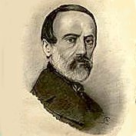
Giuseppe Mazzini, the Soul of Italian Unification, an Italian patriot spearheaded a national revolutionary movement. Mazzini's ideology of an independent integrated republic spread quickly among large segments of the Italian people. Revolutionary cells formed throughout the Italian peninsula. He created the secret society “Young Italy” that was devoted to creating a United Italy. His speeches led to the rise in Italian nationalism throughout the peninsula.
Massive reforms that took place during the 1840s in the Papal States which are states controlled by the Pope and Catholic church, Lucca, Tuscany, and the Kingdom of Sardinia were intended to slow the revolutionary movements, instead these reforms (1846 and 1847) only intensified the resolve of the revolutionary groups culminating in the Revolutions of 1848, that spread to Germany, the Austrian Empire, France, and parts of northern Italy.
The first revolution on the Italian peninsula took place in the Kingdom of Sicily, which resulted in a constitution for the whole kingdom. An insurrection in 1848 caused pope Pius IX to flee Rome and a republic was proclaimed. King Charles Albert of Sardinia mobilized his army and marched to the assistance of Lombardy and joined in the war to drive the Austrians from Italian soil. Mazzini would set up a new revolutionary republic in Rome in1849.
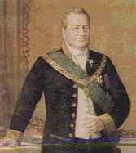
While it initially looked as if the independence and unity of Italy was a realistic possibility, the Austrians defeated the people of Piedmont and Charles Albert had to abdicate or give up his throne. His son, Victor Emmanuel II, succeeded him in 1849. A new revolutionary leader, Giuseppe Garibaldi, could not avoid Rome's destruction by the French in 1849. Only Sardinia held firm to their constitutional government
Count Camillo di Cavour, the Brain of Italian Unification became prime minister of the Kingdom of Sardinia In 1852. It was his leadership and accommodating policies that led to the unification of Italy in little more than a decade. Like Bismarck, Cavour believed in the use of realpolitik.
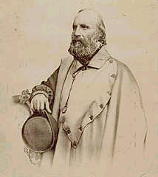
Cavour was able to persuade Napoleon to a secretly planned war against Austria. By early 1859, Cavour had caused a crisis that provoked the Austrians to send an ultimatum (a final demand or statement of terms, the rejection of which will result in retaliation) demanding the people of Piedmont disarm. As part of the "plan", Cavour rejected the ultimatum which led to the subsequent war with the Austrians. The French came to the aid of Piedmont and the Austrians were defeated in the two major battles. The Austrians were forced to surrender Lombardy, with its great city of Milan, to Napoleon III. Finally, in 1859, Napoleon transferred Lombardy to the sovereignty of Victor Emmanuel II.
Following elections during 1859 and 1860, all northern states (of the Italian peninsula), except Venetia, which was still part of Austria, joined the Kingdom of Sardinia. Napoleon's growing concern with respect to the sudden (large) size of his neighbor was resolved in part by the cessation of the Sardinian provinces of Savoy, near the Alps, and Nice, on the Mediterranean coast to France in 1860. After 1860, the only French presence on the Italian peninsula was in the city of Rome, where French troops remained at the request of the pope.
Giuseppe Garibaldi, the Sword of Italian Unification, was an Italian nationalist revolutionary hero and leader in the struggle for Italian unification and independence. Born in 1807 in Nice, France, he joined Mazzini's movement in 1833. In 1834 Garibaldi was ordered to seize a warship, but the plot was discovered by police and he was condemned to death. He escaped to South America, where he lived for 12 years. There he displayed unusual qualities of military leadership while participating in the revolt of the state of Rio Grande do Sul against Brazil, as well as later in a civil war in Uruguay.
In 1848, Garibaldi traveled to the United States settled in Staten Island, New York, and later became a US citizen. During the same year he returned to Italy and participated in the movement for Italian freedom and unification, which became widely known as the Risorgimento (Italian for "revival"). He organized a corps of volunteers, known as the “red-shirts”, which served under the ruler Charles Albert, king of Sardinia. He unsuccessfully waged war against the Austrians in Lombardy and led his volunteers to Rome to support the Roman Republic established by Mazzini and others in 1849. Garibaldi defended Rome, initially successfully, against French forces, but in the end was forced to "settle" with the French. He was allowed to depart from Rome with about 5000 of his followers. However, the line of retreat reached directly through Austrians controlled territory. Garibaldi's force was killed, captured, or dispersed during his attempt to retreat, and Garibaldi had to flee Italy to save his life.
He returned to Italy in 1854 where he settled down northeast of Sardinia. By this time, Garibaldi had separated politically from Mazzini, and had formed an alliance with Victor Emmanuel II, the king of Sardinia, and his premier, Camillo di Cavour. Given Garibaldi's popularity and large following, thousands of Italians gave their allegiance to the Sardinian monarch.
Garibaldi's dream of a united Italy motivated his successful expedition against the Austrian forces in the Alps in 1859. In 1860 he conquered Sicily and set up a provisional government. Cavour feared that Garibaldi’s success in the south would lead to a permanent division between northern and southern Italy. Adding to this fear, Garibaldi then conquered Naples. Cavour urged King Emmanuel II to send troops south to deal with Garibaldi; these troops instead would link up with Garibaldi and his men. In a patriotic move, Garibaldi delivered these lands to Victor Emmanuel in 1861. Victor Emmanuel was crowned king soon after. The Italian kingdom was missing Rome, which was still a papal (the Pope’s) possession, and Venice, which was controlled by the Austrians.
Cavour died in 1861. His successors would land a deal with Bismarck after the Austro-Prussian War which would allow the Italians to obtain Venetia. Finally in 1870, France would be forced to withdraw from Rome. For the first time since the fall of the Roman Empire, Italy was united.
Task: Using the reading above, provide evidence in the graphic organizer below discussing the three leaders of the Italian unification movement, and why they each received the nicknames that they did. What events or actions led to these nicknames? And what role did each play in the fight for Italian unity?
The Soul | The Brain | The Sword

Task: Answer the following questions using evidence from the text.
1. Why is the city of Rome so important to the Italian unification movement and Italian nationalism?

2. Who was crowned the King of Italy?
3. How did the Austro-Prussian War benefit the goal of Italian Unification?

4. How did Cavour provoke the Austrian Empire into war with France? What was the outcome of this war? How did this benefit the goal of Italian Unification?

4a. Explain how this is an example of Cavour’s belief in realpolitik.

5. What was the source of conflict between Garibaldi and Cavour? What did Cavour fear? How was conflict resolved?

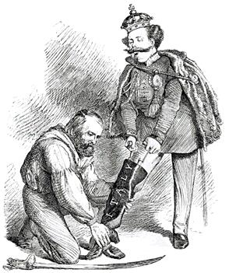
5. How did Italy finally become fully unified?

Task: Analyze this political cartoon and answer the questions below in regards to Italian unification.
- Who are the two men in the political cartoon?

- Explain what is happening in the political cartoon. What event from Italian unification is this cartoon illustrating?

