Name Date:
Period:
The Unification of Germany, 1848-1871
What is Zollverein?

Chancellor .
A diplomatic genius, Bismarck invented a new political strategy called realpolitik based primarily on practical and material factors, rather than ideological notions. Instead of making decisions based off of moral or ethical factors, Bismarck relied upon economic and military analysis of his foes. Bismarck’s actions were careful, calculated, and effective. Known for his domineering and aggressive personality, Bismarck pledged to conquer his neighbors under a policy of ‘blood and iron’
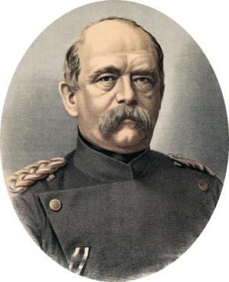
Explain his idea of ruling Germany through Realpolitik:

Task: Analyze the following statement in regards to the Unification of Germany. What does this statement mean? How will Germany (Prussia) achieve the goal of Unification?
“Prussia must concentrate and maintain its power for the favorable moment which has already slipped by several times. Prussia's boundaries according to the Vienna treaties are not favorable to a healthy state life. The great questions of the time will not be resolved by speeches and majority decisions—that was the great mistake of 1848 and 1849—but by iron and blood.”(1862)

Task: Define the following:
Militarism:

Task: Read and analyze your assigned passage provided. While reading. Consider the following- How did “blood” symbolize Bismarck’s efforts to unite Germany? And how did Iron symbolize Bismarck’s effort to unite Germany? And provide examples and evidence from the text in the graphic organizer below. After you complete your assigned section of the graphic organizer, take turns teaching each other what you have discovered about the “blood and iron” of a newly unified German nation.
Blood | Iron

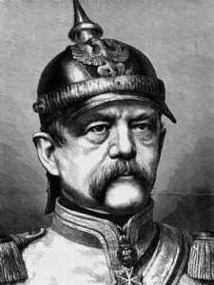
.
Blood
One hundred and fifty years ago, on September 30, 1862, Otto von Bismarck gave his famous “Blood and Iron” speech before the Prussian legislature. In his speech, Bismarck claimed that the international policy of a modern state is built upon the willingness to fight — blood — and the willingness to spend vast amounts of public treasure in creating giant armies — iron.
"The great questions of the time will not be resolved by speeches and majority decisions ... but by iron and blood," the minister president of the Kingdom of Prussia said. Nine years later — after the expenditure of plenty of blood and iron — Bismarck became the first chancellor of the new German Empire.
Less than two years after the speech, in 1864, Bismarck maneuvered Prussia and Austria into fighting an aggressive war against Denmark. The war was quickly won by the two larger nations, both of which gained additional territory.
In 1866 Bismarck instigated an aggressive war by Prussia against its erstwhile ally Austria, which was defeated in a mere seven weeks. Bismarck’s terms drove Austrian influence out of northern Germany, leaving Prussia with effective hegemony.
In 1871 Bismarck tricked France into a war against Prussia that resulted in a crushing Prussian victory and the addition of all the smaller German states around the Rhine into the new German Empire. This empire included a large number of smaller German states that had been quite happy to remain independent but that felt pressured and helpless after the collapse of France.
The series of wars did not happen by accident. They were part of Bismarck's calculated plan of power politics, aggression, and annexation. The realpolitik Bismarck defined in his famous “Blood and Iron” nine years earlier had given birth to the German Empire.
A state policy of huge armies and an aggressive attitude toward neighbors threatens liberty and morality in different ways. First, of course, a nation engaged in an arms race like Bismarck’s Prussia can not only plot wars but can also stumble into wars, as was the case in the First World War.
Second, arms races dramatically increase national government spending, so after 1871, the German Empire, France and Britain all increased military spending (reducing the amount of their wealth that taxpayers could keep). It is impossible to have a vast, sprawling military without also having a vast, sprawling government.
Third, reliance upon force rather than consent — upon military power rather than treaties, trade and legal immigration — is no path to long term peace, prosperity, or moral government. Our nation was founded upon the theme that we would be on friendly and peaceful terms with any nation that would be on friendly and peaceful terms with us.

Iron
Before 1870 Germany was not united properly. This was because of the power struggle, mainly between Prussia and Austria, that was occurring at the time. This disunity did not provide for a stable or flourishing economy, and so Germany was not very advanced industrially at all.
Then Bismarck finally got his way, and in 1871 everything changed. The New German Confederation was formed, and all the German states were united under one ruling body. This unification provided a base platform for industry to grow, and Bismarck cared for this well. He implemented several policies to protect growing businesses; among them were laws which increased the cost of foreign products and made German goods cheaper. This strengthened the economy and industry responded. After this there was no stopping anyone; the economy was up and running. Germany then went through a period of rapid industrial growth.
To consolidate their economic power, the German government heavily subsidized industrialization, increasing coal, steel, and iron production. Stressing the importance of high-speed, reliable transportation to stimulate economic and industrial growth, Bismarck ordered thousands of kilometers of railroads laid. From 1871 to 1913, the total length of German railroad tracks increased from 21,000 to 63,000 kilometers, making it the largest rail network in Europe.
In addition to Germany’s rapid industrialization, Bismarck set out to redesign German society on the ideals of nationalism and efficiency. To encourage worker production and cultural unity, Bismarck turned the German Empire into the world’s first welfare state. He passed laws giving German workers health, accident, and maternity benefits, as well as a national pension scheme. Effective and popular amongst the working class, many of the social security systems installed by Bismarck are still used in modern day Germany.
