Name: Date:
10th Grade Social Studies Period:
The Powder Keg of Europe: The Balkans
Task: Answer the following questions while watching the video.
- What two Empires maintained control over the Balkan region prior to the outbreak of World War One?

- What nations in the Balkans consider themselves to be Slavic? What is this Pan-Slavic nation they want to form?

- What Slavic nation was formed in 1878? What empire did they break away from? How can you characterize this nation?

- What is the only way the Serbians would be able to unite the Southern-Slavic people? Who would they need to defeat?

- In what ways did Serbians alienate outsiders and minorities?

- What is the Black Hand? What type of organization was this? What did this organization do?

- How did Italy’s war against the Ottoman Empire affect the Balkans region?

- What are some of the outcomes of the Balkan wars? Why

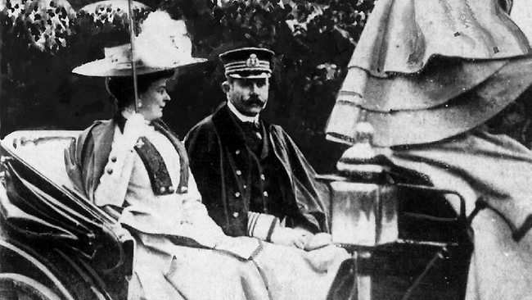
The Powder Keg Ignites: The Assassination in Sarajevo
The crisis began when Archduke Francis Ferdinand of Austria-Hungary announced that he would visit Sarajevo, the capital of Bosnia. Ferdinand was the nephew and heir of the Austrian emperor, Francis Joseph. At the time of his visit, Bosnia was still under the rule of Austria-Hungary. Bosnia was also the home of many Serbs and other Slavs. News of the Royal visit angered many Serbian Nationalists. They viewed the Austrians as foreign oppressors. Some members of the Black Hand, a Serbian terrorist organization vowed to take action.
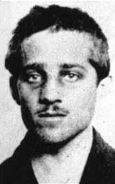
The Archduke ignored the warnings of anti-Austrian unrest in Sarajevo. On June 28, 1914 he and his wife rode through Sarajevo in an open car. As the car passed by, a conspirator named Gavrilo Princip seized the opportunity and fired twice into the car. Moments later the archduke and his wife were dead.
How do you think Austria will react to the assassination of the Archduke Francis Ferdinand?

Austria Strikes Back: The news of the assassination shocked the Austrian emperor. Still, he was hesitant to go to war. The government in Vienna, however, saw the incident as an excuse to crush Serbia. In Berlin, Kaiser William II was horrified at the assassination. He wrote to Emperor Francis Joseph, advising him to take a firm stand towards Serbia. Germany gave Austria a promise of unconditional support, regardless of the cost.
Austria sent Serbia an ultimatum, or final set of demands. To avoid war, Serbia must end all anti-Austrian activity and punish any official involved in the assassination plot. It must even let Austria participate in the investigation. Serbia agreed to most of the demands, but not all of them. This partial refusal gave Austria the opportunity it was seeking. On July 28, 1914, one month after the assassination, Austria declared war on Serbia.

What happened because of the assassination of Archduke Ferdinand and his wife?

What nation do you believe will come to the aid of Serbia after war is declared in 1914? Why would they feel obligated to do so? How might this affect Europe as a whole?

Do you believe that the Balkans was the powder keg of Europe? Why or why do you not believe this is an accurate description?

- the Balkans was considered the powder keg of Europe?

